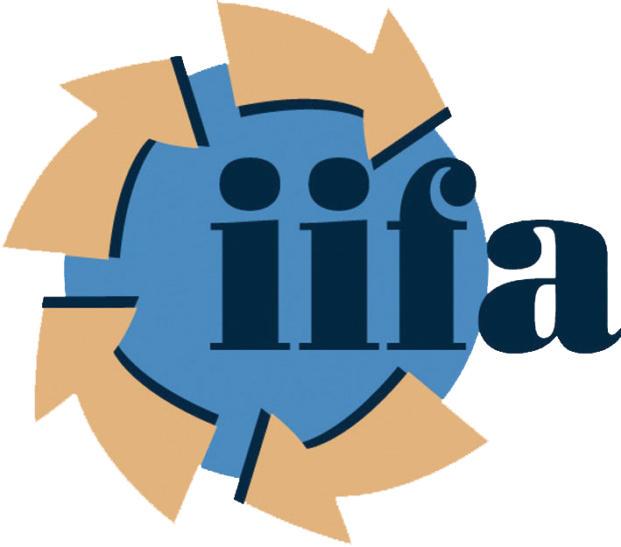
Irish International Freight Association

BREXIT Preparation Toolkit

With BREXIT Negotiations have formally commenced on 19th June 2017, the following months will shape the future of trade relationship between the United Kingdom and the European Union and indeed more specifically between the United Kingdom and Ireland.

While clarity on future trade is not expected for some time, there are a handful of small steps which businesses can take today in order to prepare for a post-BREXIT world.

It is widely accepted that some form of Customs Clearance will be introduced between Ireland, the United Kingdom and the European Union, at the very least as a monitoring process. Across the next two pages are 5x actions which will help businesses become ready to engage with and operate through Revenue’s Customs Clearance procedures.

Economic Operator’s Registration and Identification System (EORI) Page 2
Identifying TARIC code for your goods Page 2
Consider Alternative Suppliers from Continental Europe Page 2
Authorised Economic Operator (AEO) Page 3
Examine the process and cost of guarantees for VAT and DUTY Page 4

further detail on any or all of the above items is available through request from the IIFA Office via
Tel: 01 845 5411 / E-Mail: info@iifa.ie

Recommended Further Reading Page 5
Further Assistance for BREXIT Preparations Page 5

IIFA’s Customs Awareness and Practical SAD Completion course will launch in September 2017. Further details about this course can be found on page 5 of this document.

Economic Operator’s Registration and Identification System (EORI)

What is an EORI Number?

Individuals and Companies engaged in customs-related activities in the EU need to register under the Economic Operators Registration and Identification (EORI) system.

The basic purpose of EORI was to establish a system whereby every trader who interacts with the Customs Authorities in any Member State of the EU is allocated a unique reference number.

How do I get an EORI Number?

Revenue has set up an online registration service for companies to register for an EORI Number. Traders will require their Revenue Online Service (ROS) login details, a valid ROS digital certificate and a registration for customs and excise in ROS.

A step-by-step guide for EORI Registration on ROS is available via the below link on Revenue’s website:
http://www.revenue.ie/en/customs-traders-and-agents/documents/electronic/ereg-eori-guide.pdf

Identifying TARIC code for your goods

What is a TARIC code?

If a business imports or exports goods into or out of the European Union (EU), the business must classify those goods for customs purposes. Every product has a specific code.

This classification code determines the amount of Customs Duty a business will pay on imported goods. Traders can use the EU TARIC database to classify their goods to the appropriate ten digit code that will be needed to import or export goods.

How do I identify my TARIC code?

Revenue can assist with identification of TARIC codes via their AEP helpdesk through
Telephone helpline:
Revenue’s AEP/eCustoms Helpdesk is available from 9.00am - 5.00pm, Monday to Friday.
1890 204 304
+353 67 63139

Alternatively, a Business can contact their Freight Forwarder/ Customs Broker for advice in this area.

Consider Alternative Suppliers from Continental Europe

A worst-case scenario for BREXIT would introduce tariffs on goods entering Ireland from a Third Country, which is what the United Kingdom could be classed as pending the result of negotiations.
While guidance can be obtained by researching WTO guidelines on potential tariffs, this research cannot guarantee the structure of post-BREXIT trade between Ireland and the UK. In the meantime, Traders are encouraged to begin to source alternative Suppliers for raw materials within the EU as a means of back-up plan for a worst case scenario.
Authorised Economic Operator (AEO)

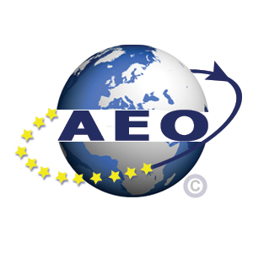

What is AEO?

The AEO concept is based on a Customs-to-Business partnership. Traders/ Economic Operators who voluntarily meet a wide range of criteria work in close cooperation with customs authorities to assure the common objective of supply chain security and are entitled to enjoy benefits throughout the EU. AEO status is a certified standard issued by customs administrations in the EU and successful companies can advertise their status through use of the AEO Logo.

What are the benefits of AEO status?

- fewer physical and documentary based controls in respect of security and safety
- priority treatment if selected for control
- possibility to request a specific place for any physical controls to be carried out
- priority handling of applications for authorisations for other Customs decisions.

How do I apply for AEO status?

Revenue have a self-assessment questionnaire and application for AEO certificate available to download on their website via
http://www.revenue.ie/en/customs-traders-and-agents/authorised-economic-operators/index.aspx

Applications can then be made to Revenue via
Tel: +353 067 63235 / 63223 / 63175 / 63103 / 63416
Fax: 067 – 32373
Email: aeo@revenue.ie
Address: AEO Section
Corporate Affairs & Customs Division,
Revenue Commissioners,
Nenagh,
Co. Tipperary

Examine the process and cost of guarantees for VAT and DUTY

What is a Customs Comprehensive Guarantee Authorisation?

A Comprehensive Guarantee may cover the amount of existing and potential customs debt and other charges, where applicable, corresponding to more than one customs operation, declaration or procedure of an Economic Operator. Upon application, an Economic Operator who fulfils the conditions may be authorised by Revenue to provide a comprehensive guarantee.

What are the benefits of a Customs Comprehensive Guarantee Authorisation?

The holder of a Comprehensive Guarantee Authorisation can:
- amalgamate all of their current customs bonds and guarantees under one comprehensive guarantee
- subject to meeting specific criteria, apply for a reduction or waiver in the amount of guarantee for debt which may be incurred
- reduce to 30% the amount of guarantee for debt which has been incurred where the operator holds the status of Authorised Economic Operator Simplified (AEOC)

How do I apply for a Customs Comprehensive Guarantee Authorisation?

Revenue have a self-assessment questionnaire comprehensive guarantee and reduction/waiver available to download on their website via
http://www.revenue.ie/en/customs-traders-and-agents/documents/self-assessment-questionnaire-for-comprehensive-guarantee.pdf

Also required for completion is Revenue’s application for a comprehensive guarantee, which is also available to download on their website via
http://www.revenue.ie/en/customs-traders-and-agents/documents/application-for-a-comprehensive-guarantee.pdf

To contact Revenue in relation to guarantees, please use:

Authorisations and Reliefs Unit
Tel: 1890 626 364 or 067 63370
Fax: 067 – 32373
Email: customsreliefs@revenue.ie
Address: Customs Division
Government Offices,
St Conlans Road,
Nenagh,
Co Tipperary,
E45 T611

Recommended Further Reading:

Inter Trade Ireland - Potential Impact of WTO Tariffs on cross border trade
published 9th June 2017

This report examines current cross-border trading patterns and considers the potential impacts on overall trade of the application of current EU WTO tariffs. The impact of Non-Tariff Barriers (NTB’s) and changes to the euro-sterling exchange rate are also examined.

http://www.intertradeireland.com/researchandpublications/publications/publications/name-43052-en.php

Further Assistance for BREXIT Preparations:

Business support groups have funding available for those SMEs seeking further advice on how to handle/ prepare an action plan for business in a post BREXIT World. Two such Business Groups offering same include:

Enterprise Ireland
https://ambition.enterprise-ireland.com/axuqhci/

Inter-Trade Ireland
http://www.intertradeireland.com/brexit/brexit-vouchers/

IIFA Customs Awareness and Practical SAD Completion course:

IIFA will launch its Customs Training programme in September 2017, which will be split into two sections:

Section 1:
An awareness of Customs Clearance, what it is and why it operates in the way that it does. This first section will take the form of a blended-learning approach; Participants will receive a manual and additional study aids through on-demand webinars and assignments for completion. At the end of the one month training for this section, Participants will be asked to complete and online multiple-choice test and return an assignment based on the knowledge within the text book.

Sections in the text book will include:
National Customs Administration, European Union Customs, Duties and Rights of Customs Administration and the Freight Forwarder, National Customs procedures, Legal Relationships between Clearance Agent and Customs. Simplified Procedures, Smuggling, Security and more.

Section 2:
This section will take the form of a Full Day class-room approach. Participants will be introduced to Customs Clearance software and shown how to operate same for a customs clearance procedure. Sample Case Studies will be utilised throughout the day and assignment shipments will be required to be completed in the days following the training, via test software still accessible to Participants.

Those interested in taking part are asked to pre-register interest with IIFA via info@iifa.ie with the subject line “Participation in IIFA Customs Clearance course” or through 01 845 5411.

